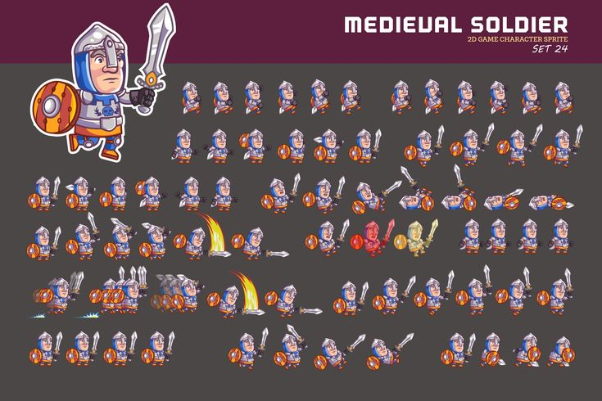

**MEDIEVAL SOLDIER**

2D GAME CHARACTER SPRITE

咖哩吧

SET 24